**User Manual**

**Of**

**Course scheduling assistant**

**Introduction:**

This project enables the faculty to view their schedule automatically. Earlier this is done manual in an excel sheet and given to faculty to see their course schedule.

Department course scheduling assistant project is to help University people like admins and instructors to schedule classes and assigning instructors to each section based on their requirements.

1. Login screen:

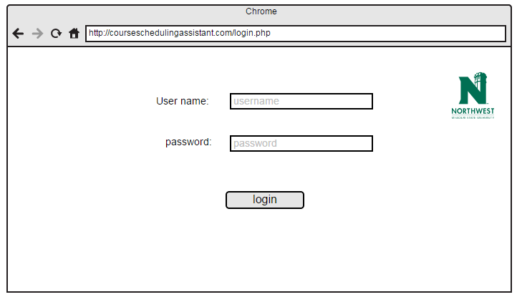

**Description:**

1. User need to provide username and password to login.
2. If the User forget his/her password, then there is a section called forget password once the user clicks it redirect user to forget password screen.

2. Home screen is displayed after the login.

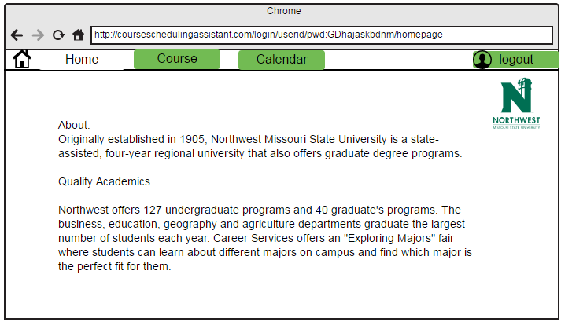

**Description:**

If user is faculty he/she will be redirected to faculty home page. If user is admin he/she will be redirected to admin home page.

3. Course view page is displayed after navigating from home page by clicking on course tab.

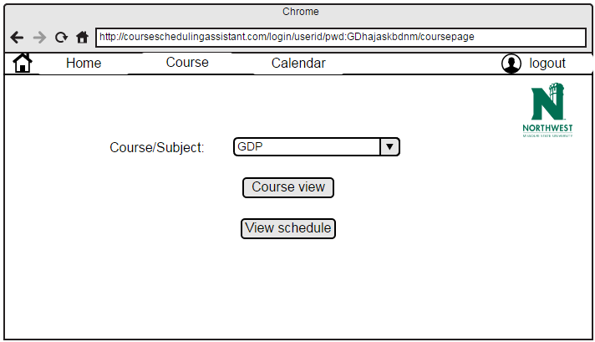

**Description:**

User need to select subject from dropdown menu and he/she has to click on the course view or on the view schedule.

4. Course view page is displayed after clicking on course view tab in course page.

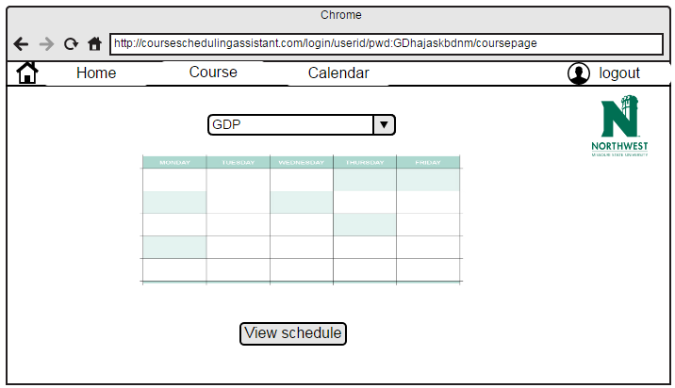

**Description:**

User need to select subject from dropdown menu and he/she has to click on the view schedule to view schedule.

5. Calendar view is displayed after clicking on Calendar tab in course page.

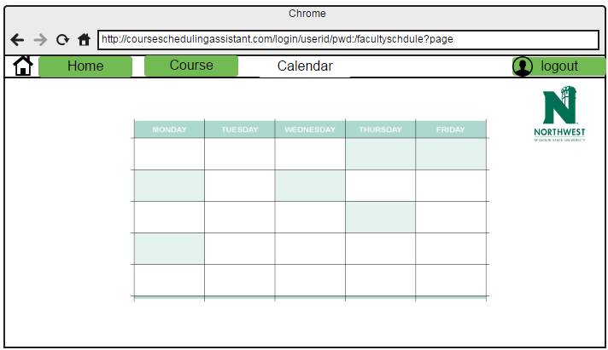

**Description:**

User will be able to view the course schedule in calendar view after clicking on view schedule tab in above screen.

6. Error message is displayed when user try to navigate to calendar page and he/she is not scheduled with classes.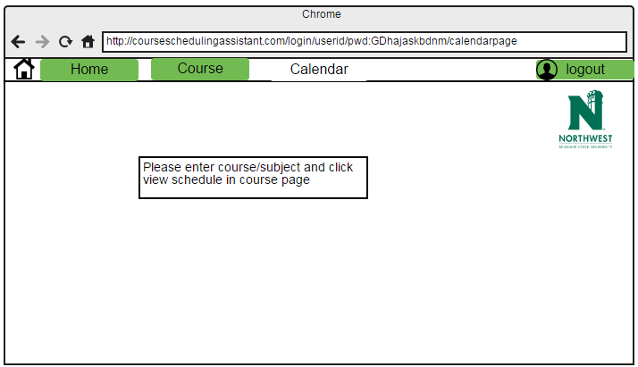

**Description:**

User will be displayed with the error message when user tried to view schedule with out selecting input.

7. If user is admin and admin want to add professor to list.

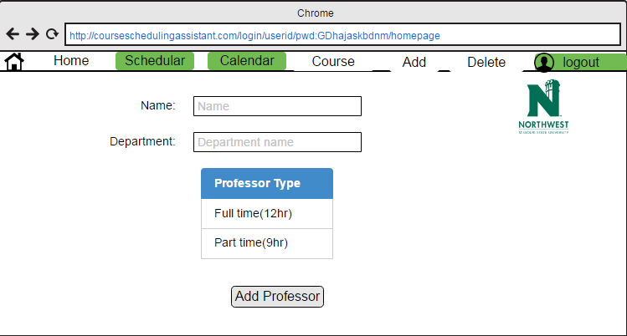

**Description:**

In this admin is going to add professor by selecting below fields:

1. Name
2. Department
3. Professor Type

Click on “Add professor “button to add faculty.

8. If admin want to delete professor from list.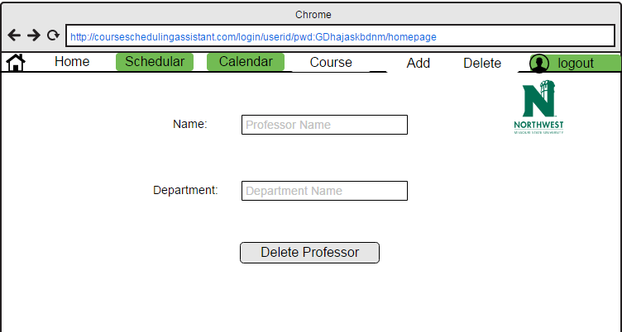

**Description:**

In this admin is going to delete professor by selecting below fields:

1. Name
2. Department

Click on “delete Professor “button to delete faculty.

9. If admin want schedule class for professor.

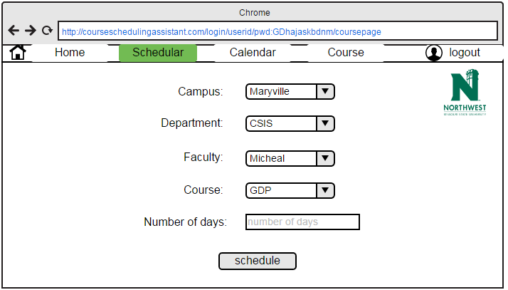

**Description:**

In this admin is going to schedule classes for professor by selecting below fields:

1. Campus
2. Department
3. Faculty
4. Course
5. No. of Days

Click on “Schedule “button to schedule classes for selected faculty.

10. Faculty schedule page with calendar which displays class room and class timings.

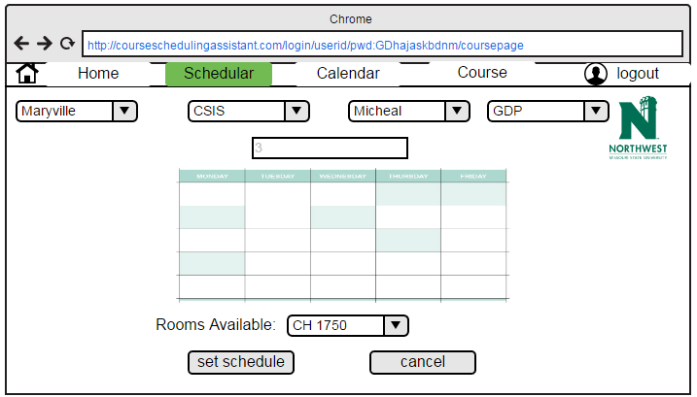

**Description:**

In this admin is going to schedule classes for professor by selecting below fields:

1. Campus
2. Department
3. Faculty
4. Course
5. Rooms Available

Click on “Set Schedule “button to schedule classes for selected faculty.

Click on “Cancel” button to cancel the scheduling classes.